Dock Levelers | 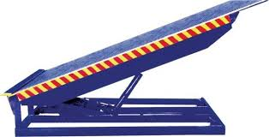
Make | NIHVA
Capacity in KG | 9000
Platform Width in MM | 2000
Platform Length in MM | 2500
Lip Width in MM | 2000
Lip Length in MM | 400
Working Length (Including Lip) in MM | 2900
Overall Length in MM | 2500
Overall Width in MM | 2000
Shut Height in MM | 485
Working Range UP/Down in MM | (+) 250 / (-) 150
Loading Platform Height from Road in MM | 4 FEET/1220mm
Dock Operation Mode | AC Power Pack Hydraulically Operated
Lip Operation Mode | Hydraulically Operated
Operation Control | Through Panel
Power Pack | Hydraulic
Drive Type | Direct by electric Motor
Motor Ratings HP / Make | 1HP
Pump Design Flow (LPM) | 2.5
Pump Type | Gear
Safety Valve Set Pressure (Kg/Sq. Cm) | 120
Volume of Oil Receiver (Liter) | 7
No. Of Deck Cylinder | 2
No. Of Lip Cylinder | 1
Power Supply | 3 Phase
Maximum Gradient | 1:10
Clear Pit Dimensions (W x L x D) MM | 2050 X 2570 X 485
Service Weight in Kg (Approx.) | 1000
Colour | Golden Yellow

